Uniform Ordering
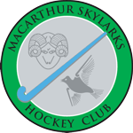

Go to our website www.revolutionise.com.au/skylarks
Click on SHOP
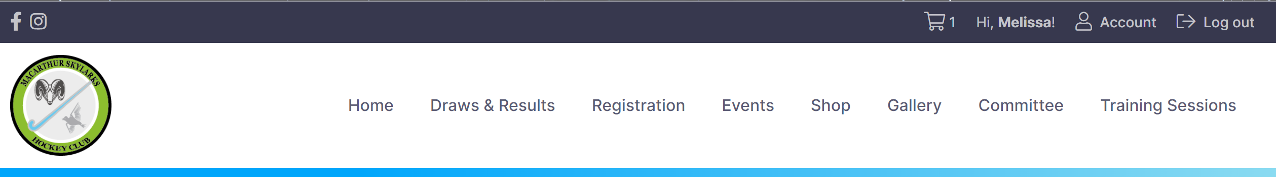

Then click on what you require to be ordered.
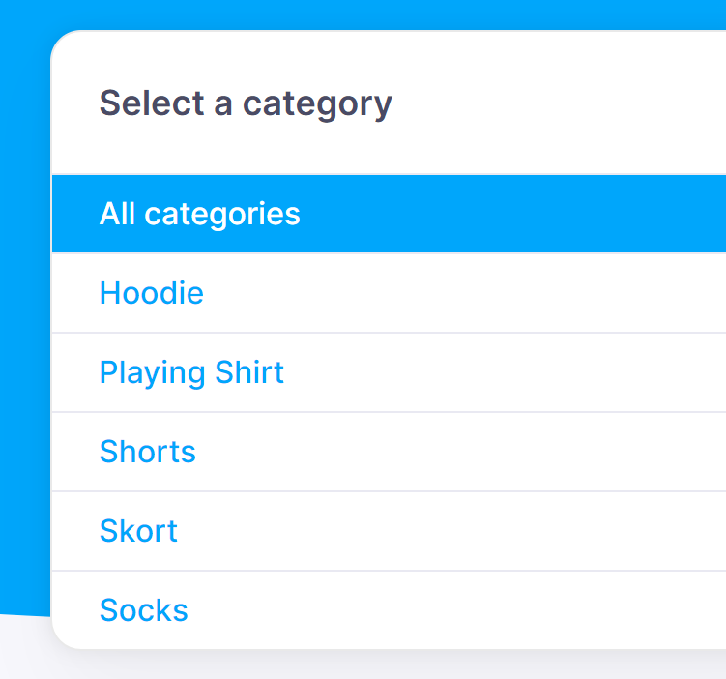
For ordering a Shirt then the below will show up. Then click on Add to cart.
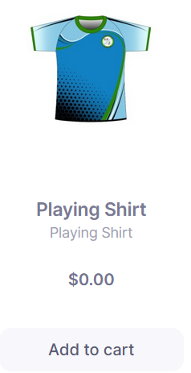
In the drop down area click on the size that you require. Then add to cart.
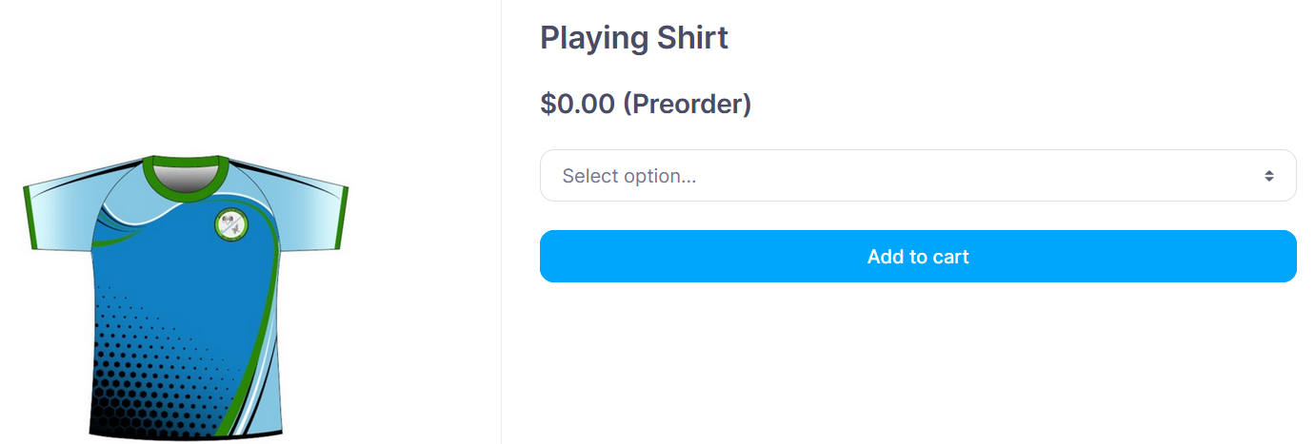

The next will show up. This will show all that you have ordered. Click on Proceed to checkout when all the uniforms you required are ordered
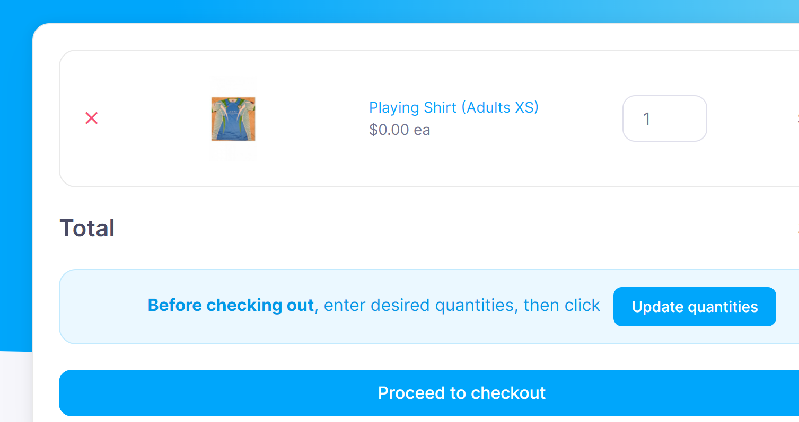

The next screen will show up. Please check all is correct as it will have your details. Then you click on Place Order.
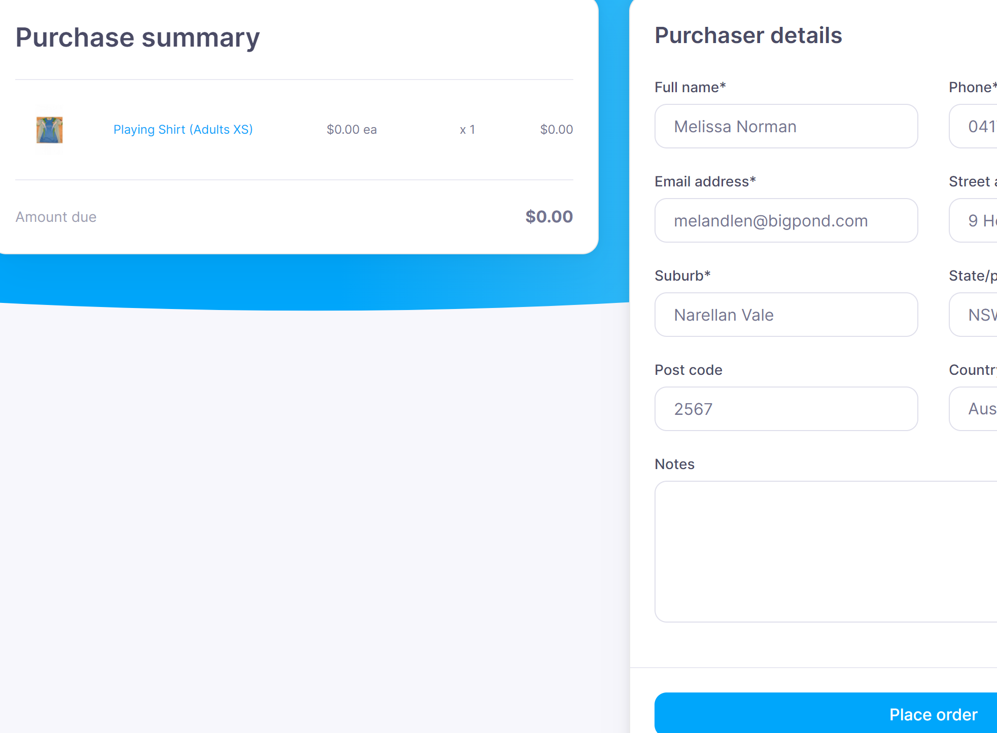

You will then receive an email from the below email address no-reply@revolutionise.com.au
You may have to check your junk or spam folder.
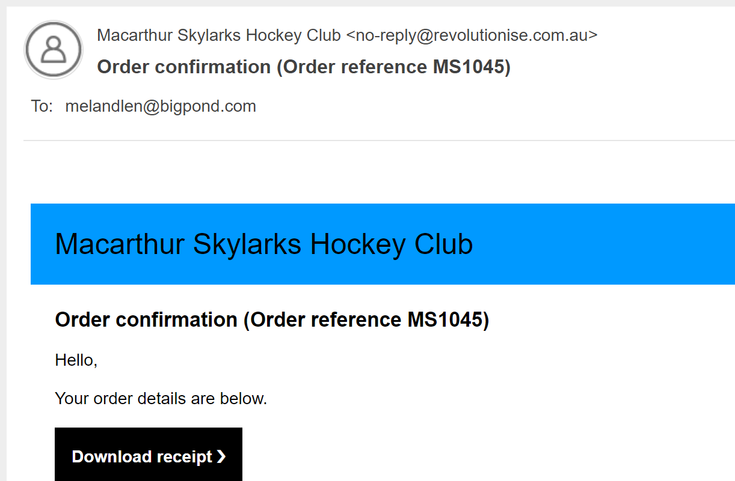

Note: If you have any issues registering online or ordering a uniform please contact skylarksuniform@gmail.com

