https://www.hockeynsw.com.au/get-involved/lgbtqi-inclusion/

LGBTQI+ INCLUSION
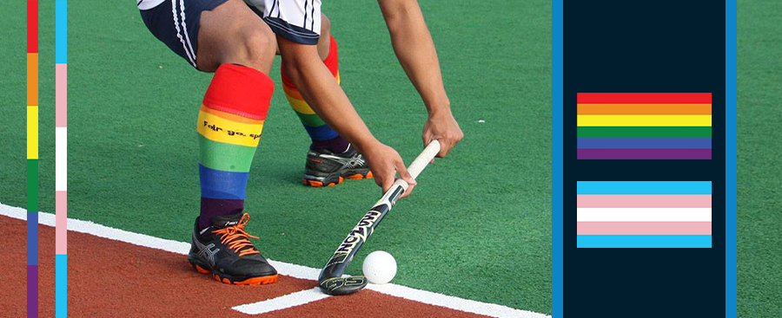
Hockey NSW is a proudly diverse organisation, who actively celebrates LGBTQI+ diversity, inclusion, and pride in NSW hockey.
Hockey NSW recognises the importance of engaging a diverse community in growing participation, as well as valuing inclusivity and understanding the social responsibilities sport has in providing opportunities for all. We are committed to changing attitudes, promoting positive language, and policies that contribute to ensuring LGBTQI+ people feel welcome, comfortable, and recognised in today’s game.
Hockey NSW has zero-tolerance for any form of bullying, harassment, and/or vilification towards people with diverse sexuality and/or genders. This includes all forms of homophobia, biphobia, transphobia and/or interphobia.
How to report homophobic, biphobic, transphobic and/or interphobic behaviour?
Hockey NSW supports Hockey Australia's Guidelines for the Inclusion of Transgender and Gender Diverse People in Community and any breach of this policy shall be dealt with in accordance with the Hockey Australia Complaints and Disputes Policy.
- If you would like to report an incident at a game day, hockey event, club training or have an unspecified hockey concern, please lodge a complaint via the Complaints and Disputes Policy which can be found listed here on our info hub page. A current email address and phone number to the Hockey Australia Complaints Manager can be found on the first page of the policy.
- The Australian Human Rights Commission or State or Territory Human Rights Commission may also assist individuals in relation to any complaints of discrimination, harassment and/or victimisation under Federal or State and Territory laws. You can lodge a complaint with the Australian Human Rights Commission by clicking here .
If you would like help with advocacy, advice or support in making a report, our partner Bentstix Hockey Club has offered their assistance as an ally for any member of the hockey community. Please contact secretary Josh Latto (he/they) at bentstix.secretary@gmail.com if you would like to confidentially speak to someone from outside of Hockey NSW.
Should you require additional support or assistance, please contact the following Hockey NSW staff members:
Ms. Corrina Bladock, Manager Community Projects at corrina.b@hockeynsw.com.au - (02) 9764 1911
Ms. Emma Highwood, CEO at emma.h@hockeynsw.com.au - (02) 9764 1911
All enquiries and support requests to Hockey NSW will be dealt with in strict confidence by our staff.

